Tree Report – David Thornber Arboricultural Consultant.
--------------------------------------------------------------------------------------------------------------
Prepared for Kevin Newsham. Clark to Rufford Parish Council

Location. Rufford Recreation Ground, Land adjacent to Oaklands Flash Lane

Report date 3rd June 2026.
Weather. Good visibility between showers.

Terms of reference.
A tree inspection was undertaken following the resident of Woodlands Flash Lane contacting the Parish Council.

Trees situated in the Recreation grounds overhanging the boundary were inspected for condition, structural safety and nuisance encroachment.

The following list of works should be undertaken in the interest of safety and to abate a nuisance.

T1 Oak overhangs driveway entrance. Low nuisance branches.
Low ‘dog-legged’ limb lowest branch extending over the tel cable. Also, minor pruning to clear tel cables.

T2 Oak. (large mature Turkey Oak) Thin low hanging limb extending to drive way and cable, minor works to thin-out lower secondary branches.
To prevent future nuisance, Remove small suppressed Oak arising from near the base of T2.
In the upper crown is a substantial dead branch which overhangs the patio area.
Consider climbing to remove.

T3 Oak Remove lowest branch extending over hedge.

T4 Oak limb extending into Rec grounds. Due to stress to bough, reduce weight on the lowest limb.

A1 several pole sized Sycamores situated between mature trees on the Rec ground in the vicinity of three mature Pine trees in the grounds of the neighbouring property.

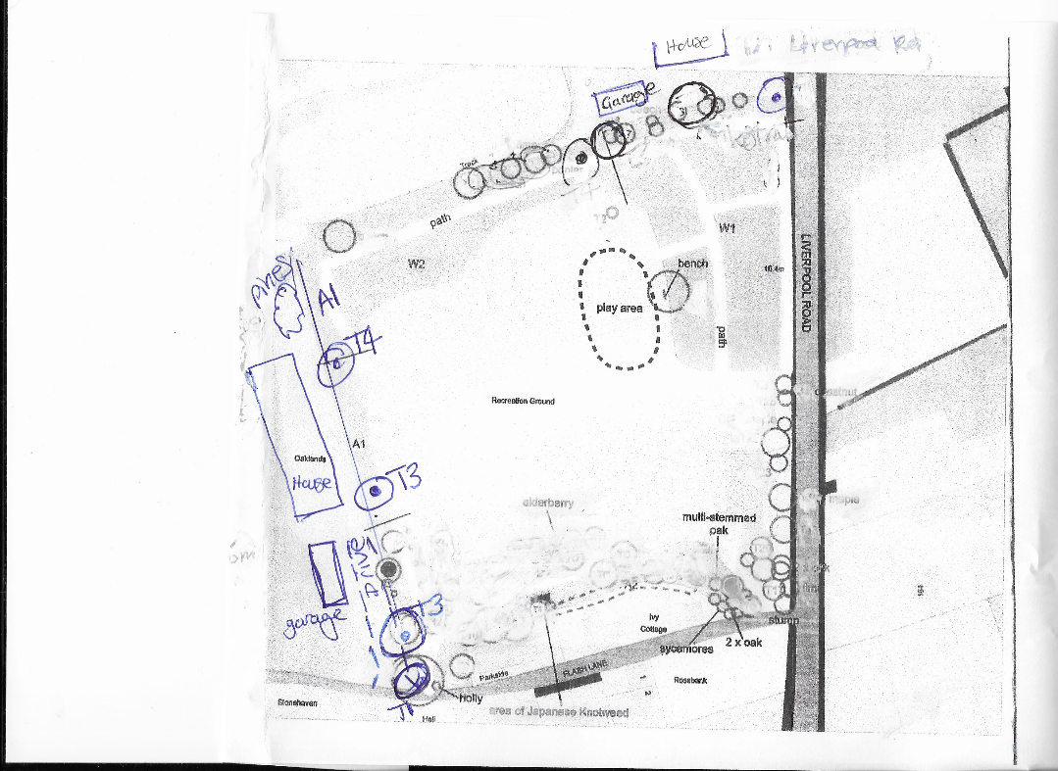
-------------------------------------------------------------------------------------------------------------------
A common law duty of care and regarding safety, which includes a common duty of care towards neighboring properties.

Also, the Occupiers Liability Acts 1957 and1984 require owners to maintain land to an acceptable level of safety.

Publications referenced.
The Body Language of Trees. A handbook for failure Analysis.
Claus Mattheck and Helge Breloer.

Limitations of the Survey/Report
All tree surveys are undertaken from ground level and trees are not climbed
as part of the inspection. No internal examination of the trees was undertaken.
At no time has the issue of subsidence been considered as part of this report.
Comments on the condition and safety of any tree relate to the condition of
the tree at the time of inspection. This appraisal is limited to a 2-year
inspection period, if more frequent tree specific inspection is required it will be
stated in the recommendations. Trees are living growing things that cannot be
guaranteed safe.
Unless otherwise specified, no checks have been conducted in respect of
statutory controls that may apply, e.g. Tree Preservation Orders, Conservation
Areas or planning conditions. In addition, prior to undertaking any tree works,
it is necessary to ensure due diligence is followed in respect of protected
species and habitats, and identifying any permissions required.
Third Party Disclaimer
Any disclosure of this report to a third party is subject to this disclaimer. The
report was prepared by David Thornber at the instruction of Kevin Newsham, and
for the use by, the clients named within the report. This report does not in any
way constitute advice to any third party who is able to access it by any means.
David Thornber Arboricultural Consultant, fully excludes lawfully permitted, all liability
whatsoever, for any loss or damage arising from reliance on the content of
this report.

David Thornber, Arboricultural Consultant, is insured for public liability and professional indemnity.

David Thornber
Arboricultural Consultant.
NDH. Tech Cert (Arbo.A). ILAM Cert. LCGI

